In Our Garden
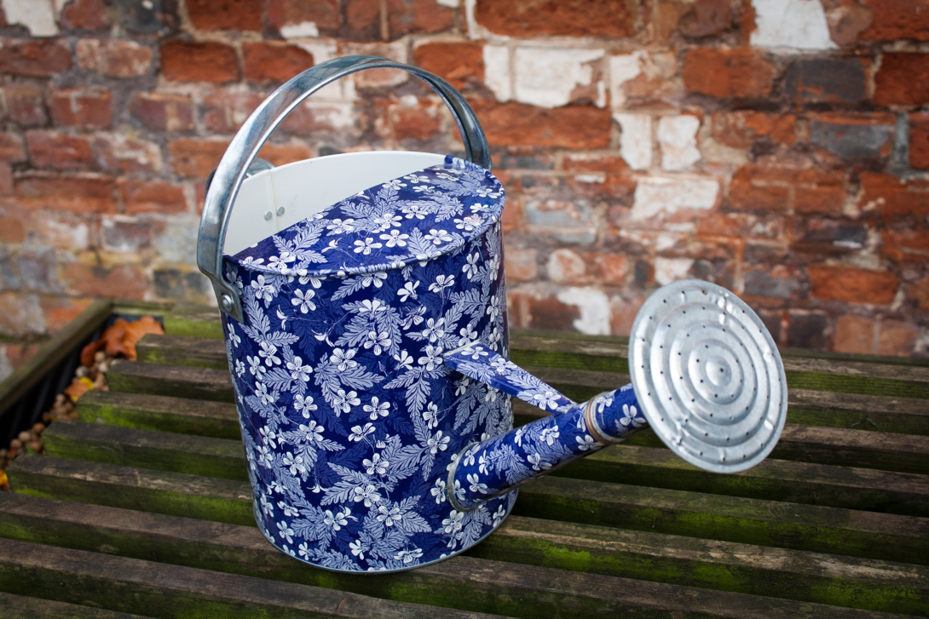

The Rotary Club of Canterbury “Let’s Stay Connected Project” has been developed as a response to an identified need within the Aged Care sector.
At times when it’s difficult to connect in person with family and friends, the Rotary Club of Canterbury has pleasure in offering you this booklet, designed to promote conversation, recollection and engagement for those who are in isolation and without their usual social activities.
The booklets have been designed for people in an aged care residence, village or at home to read by themselves, or to have a family or staff member share the booklet with them.
You can download this and other booklets from the Rotary Club of Canterbury website (www.canterburyrotary.org).
Source references for this book are held at the Rotary Club of Canterbury. Contact president@caterburyrotary.org for further details.
Material in this book was reproduced in accordance with Section 113F of the Copyright Act (1968).

Hello!
My name is Rosemary and I live in Melbourne Victoria, Australia.
I am a member of the Rotary Club of Canterbury.
There are lots of things we grow in our garden. It is a lot of work to keep it looking nice, but we enjoy it very much.
I hope you enjoy this short trip around our garden and that it brings happy memories of sights and smells, the feel of soil in your hands and the joy of growing your own food and flowers.

Rosemary

We have flowers and vegetables in our garden and some big elm trees in the back yard.
Last year we had the trees pruned.
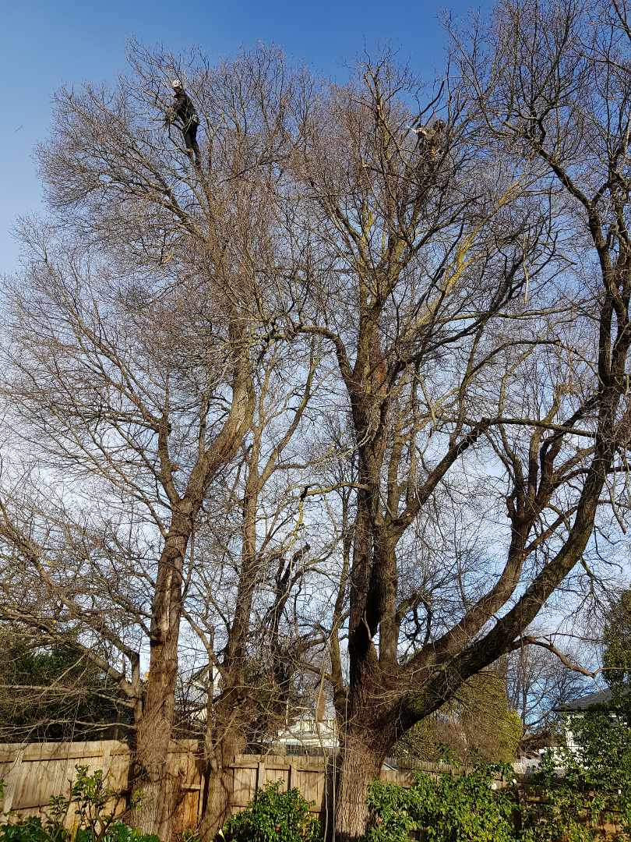

You can see the man with the chainsaw, very high up in the tree.
There was a big crow’s nest in the top of the tree.
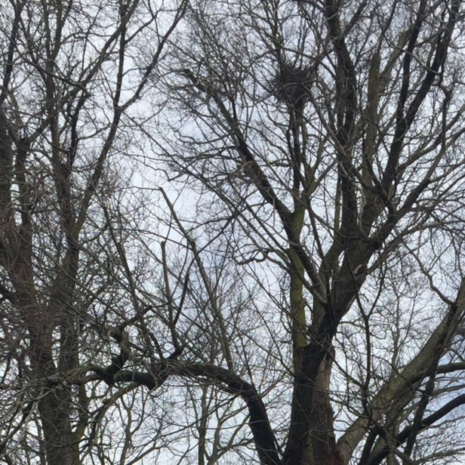
Crow’s nest

The workmen were careful not to disturb the nest, but it fell down later.
The leaves on the elm trees turn yellow in autumn.
When they fall, they make a yellow carpet on our lawn and we have to rake them up.

We have lots of flowers in pots.
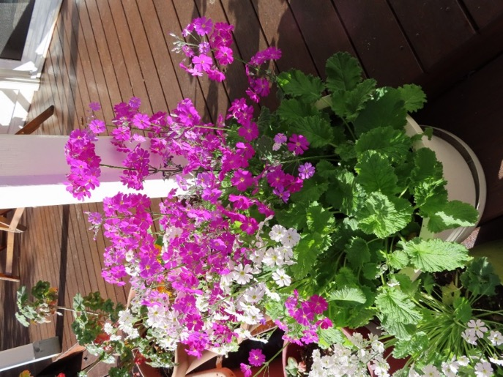

These pink and white primulas self-seeded.

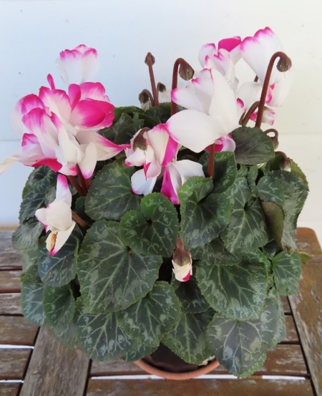

We bought the cyclamen at the nursery.

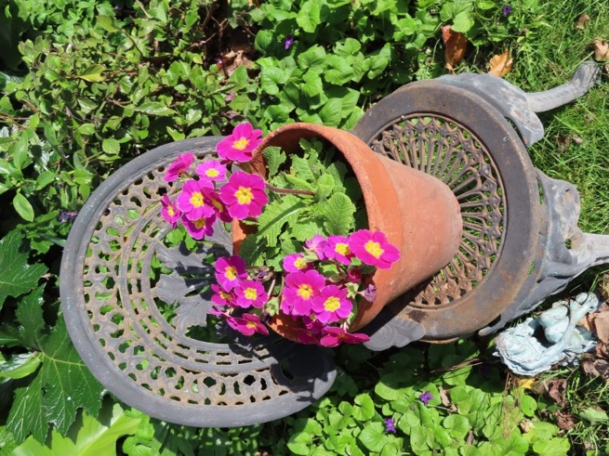
This bright pink polyanthus has flowered for 3 years in a row.

The pot is sitting on a chair that used to be in my mother’s garden.

These succulents don’t need much attention.

They are on a sunny deck where we often sit to have our lunch.
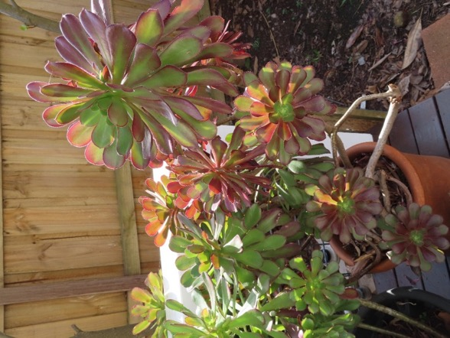

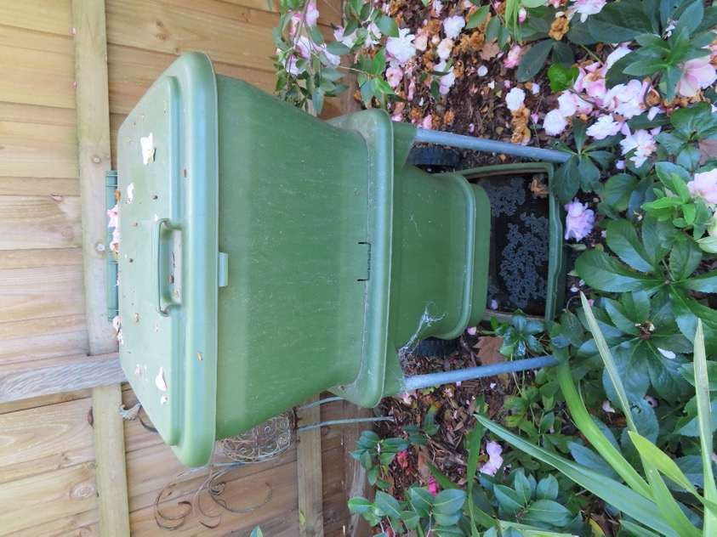

We have a worm farm that takes all our kitchen vegetable scraps.

It has a lot of worms that make lovely soil for our garden.

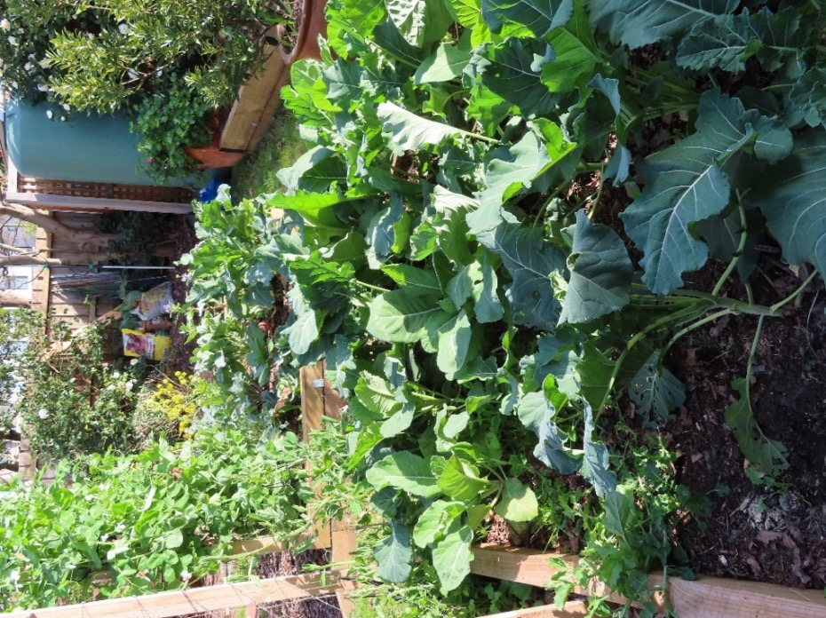

Our vegetable patch has lots of vegetables.

We have a water tank on our shed to water the vegetables.

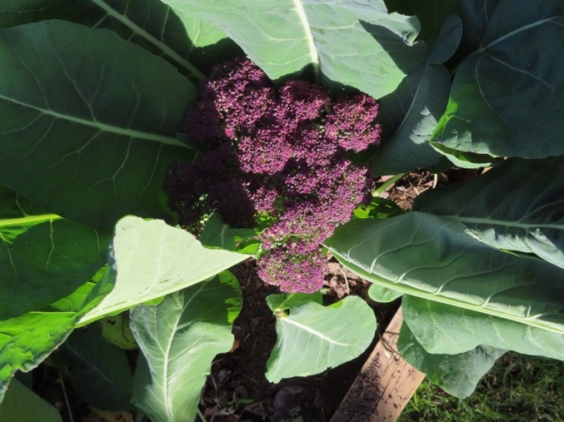
In winter we grow purple broccoli.
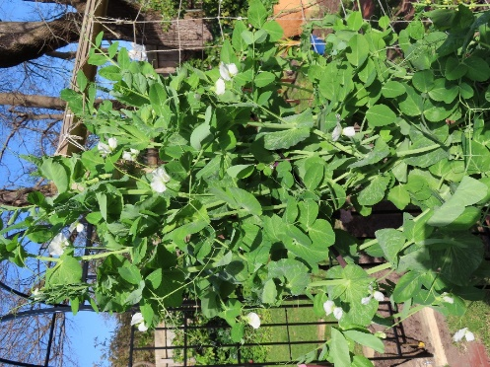

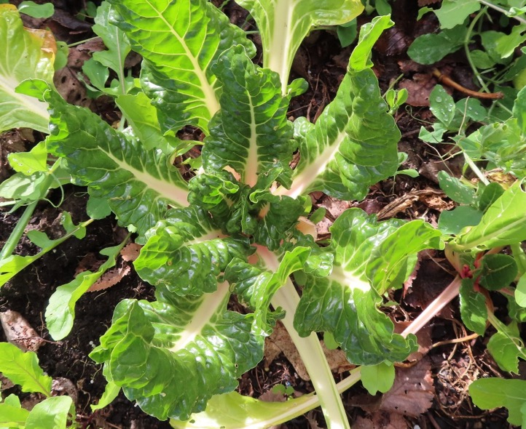
We grow snow peas….

… and silverbeet.
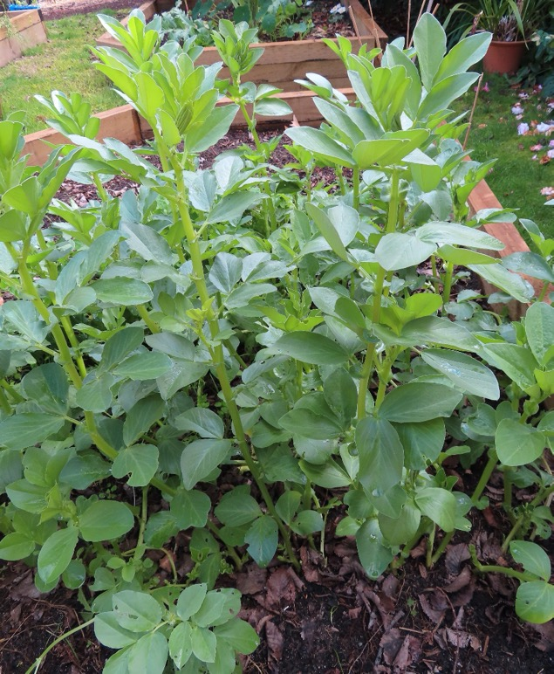
We love broad beans….

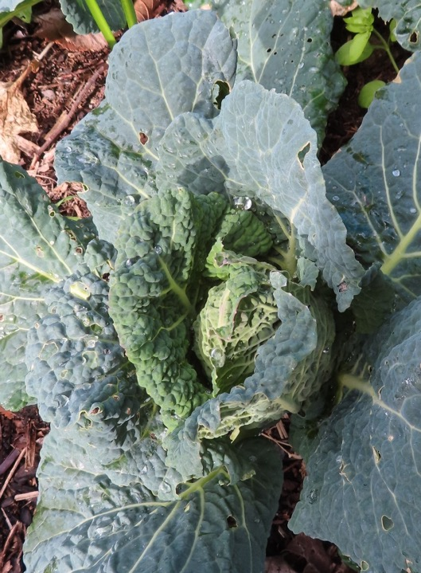
… and cabbage
In summer we grow
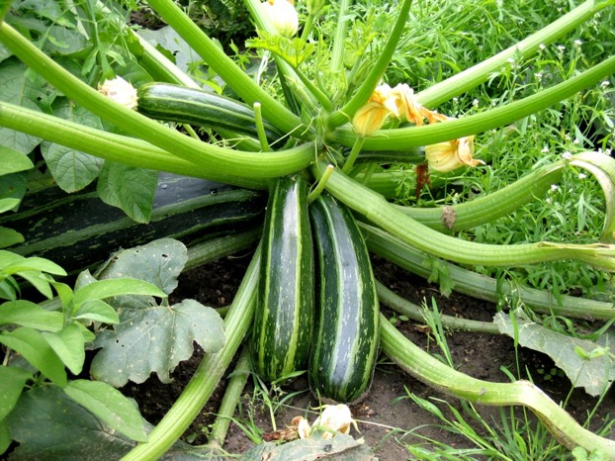
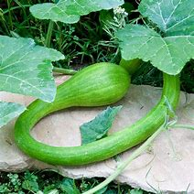
Zucchini…

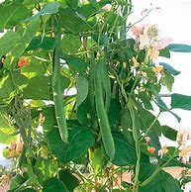
…some of our tromboncino zucchini grow nearly one metre long….

… and we have runner beans.

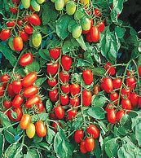
In summer, I also grow all sorts of tomatoes from seed.
Tiny tomatoes for salad

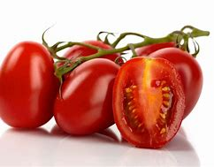
‘Italian’ tomatoes for cooking

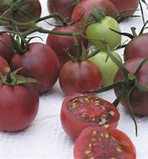
‘Black’ ones

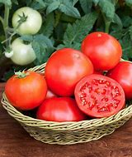

and big meaty ones.

I grow a lot of plants from cuttings – rosemary and fuchsia and many others.
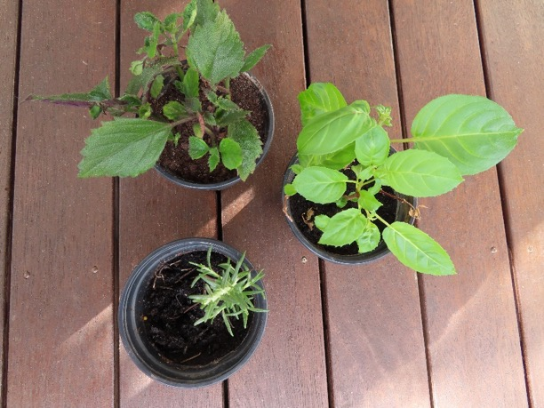

And a lot of our vegetables I grow from seed.
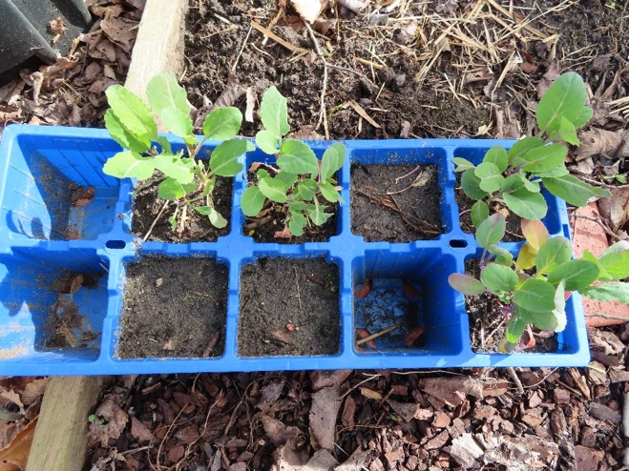

For cooking, we also have a lot of herbs in pots, like
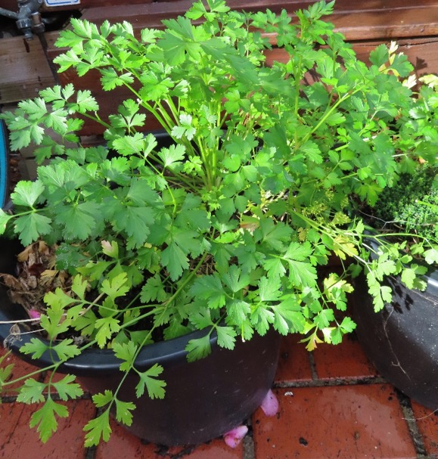

Parsley
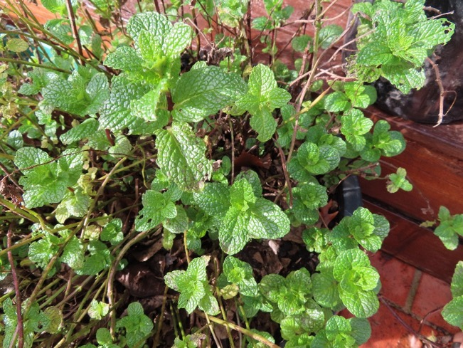
Mint
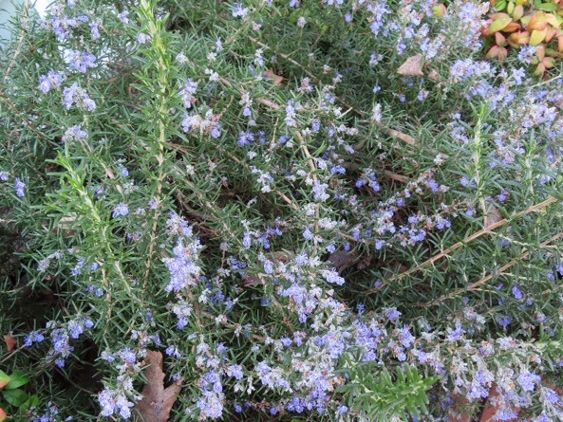

and Rosemary

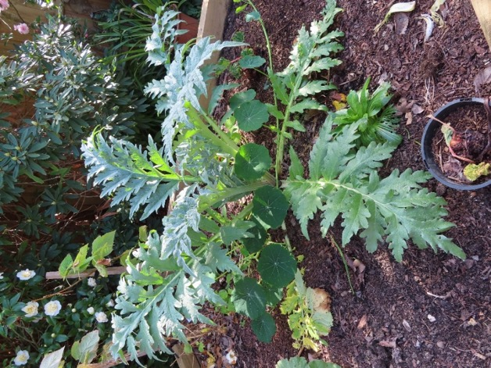
We have artichokes.
Once my husband pulled out an artichoke plant because he thought it was a thistle.

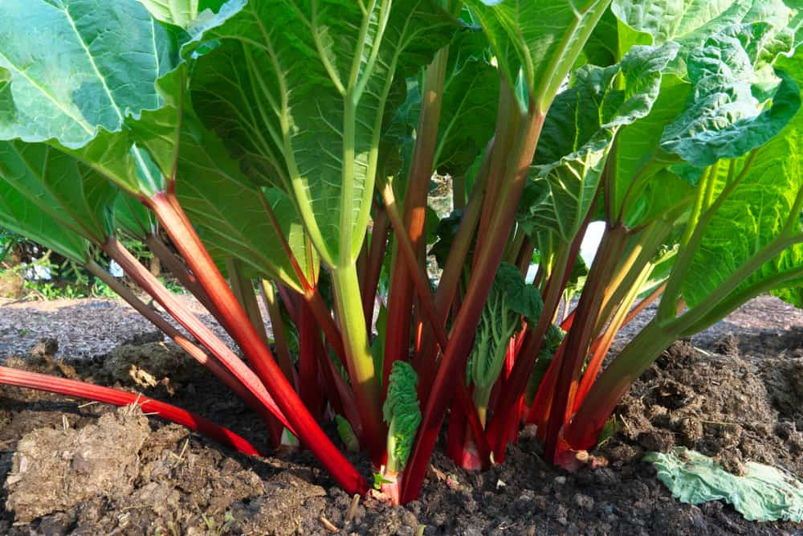
We grow a lot of rhubarb. My husband likes stewed rhubarb on his breakfast cereal.

We have lots of plants to attract the bees and butterflies.
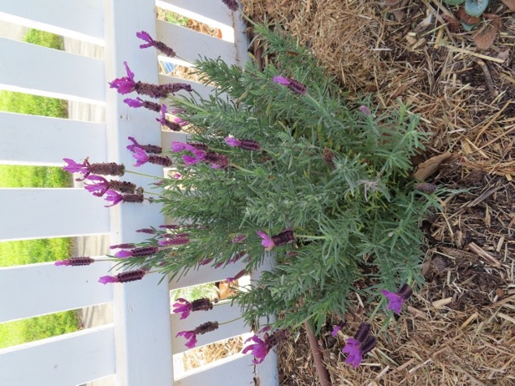
The bees love lavender.

It smells lovely on a summer evening.

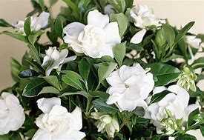
The gardenias also smell beautiful.

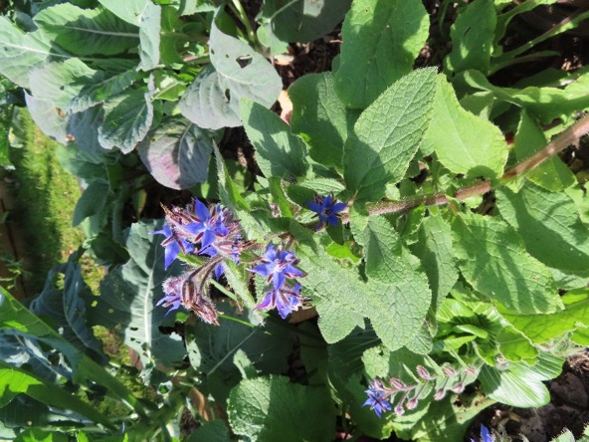
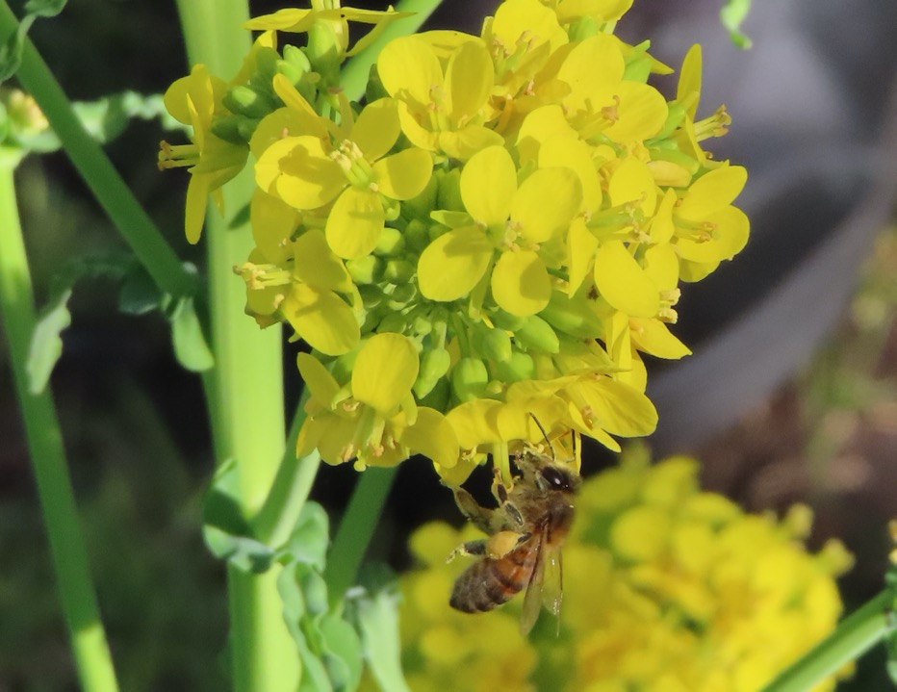
The bees love the flowers on the broccoli that went to seed.
The borage is a bit prickly, but the bees don’t mind.

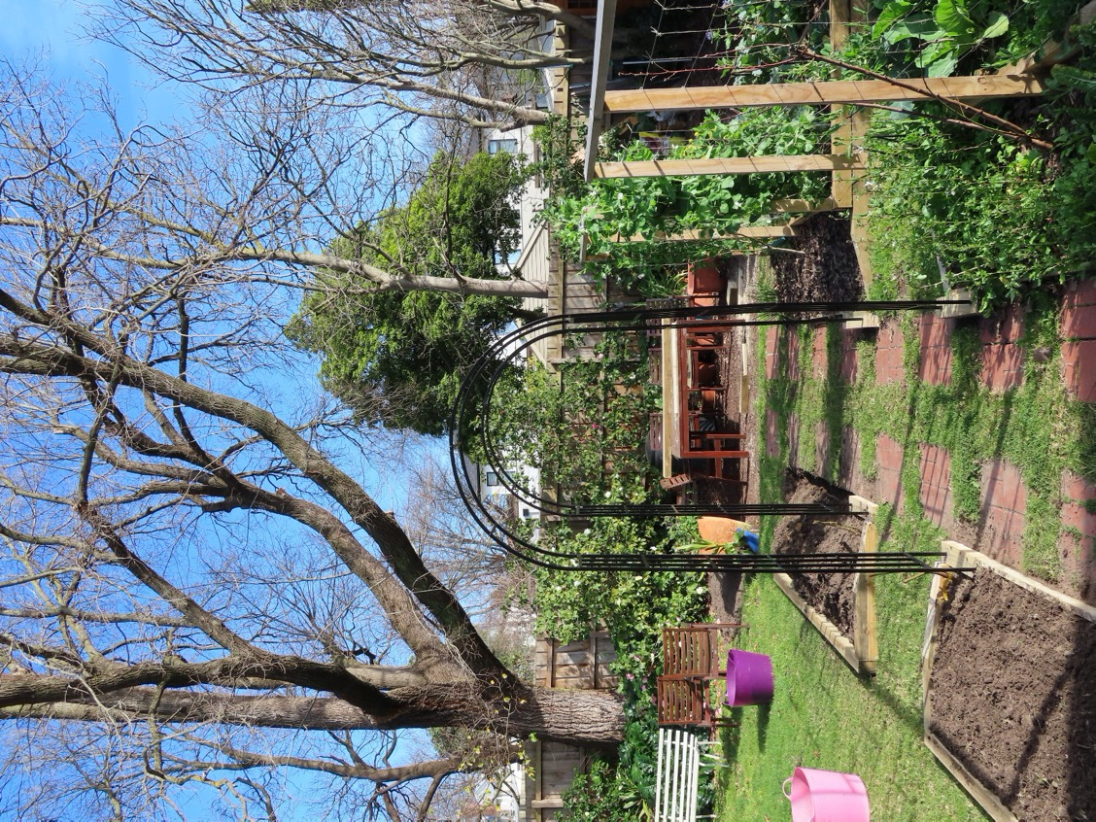
In the back garden we have made some new garden beds and planted some roses to grow over the arches.

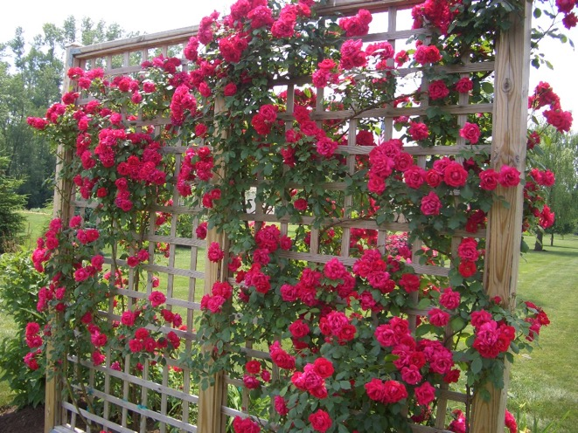
It is winter now, but in summer there are lots of roses in many different colours.

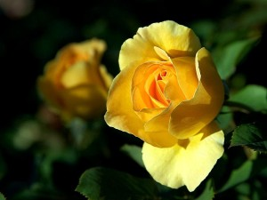

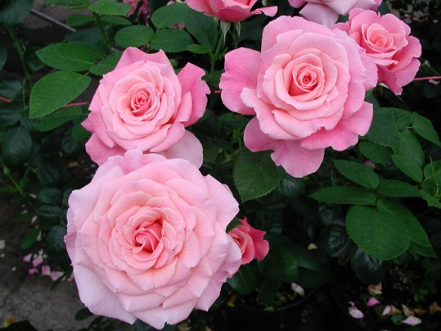

Even in winter we have lots of flowers.

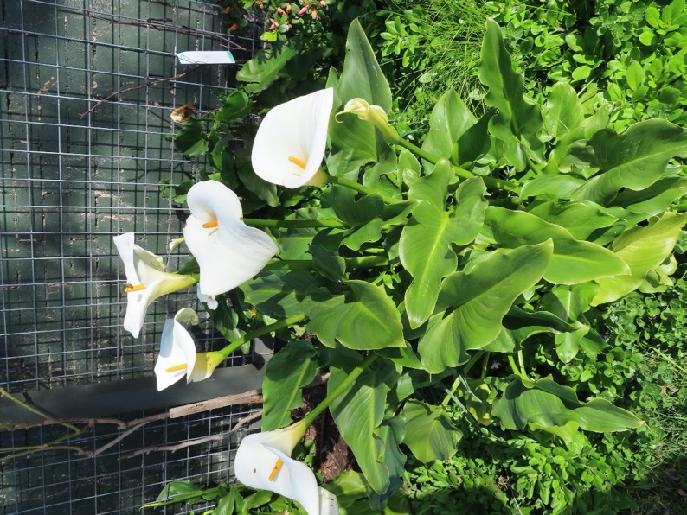
Arum lilies

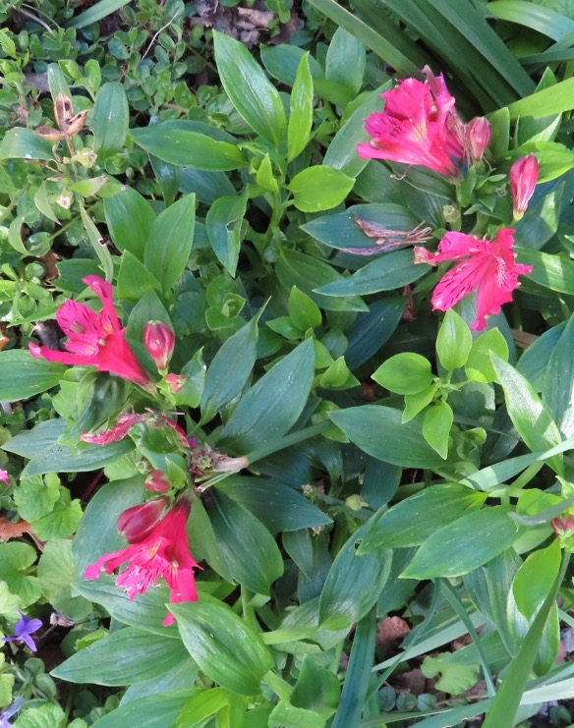

Alstroemerias

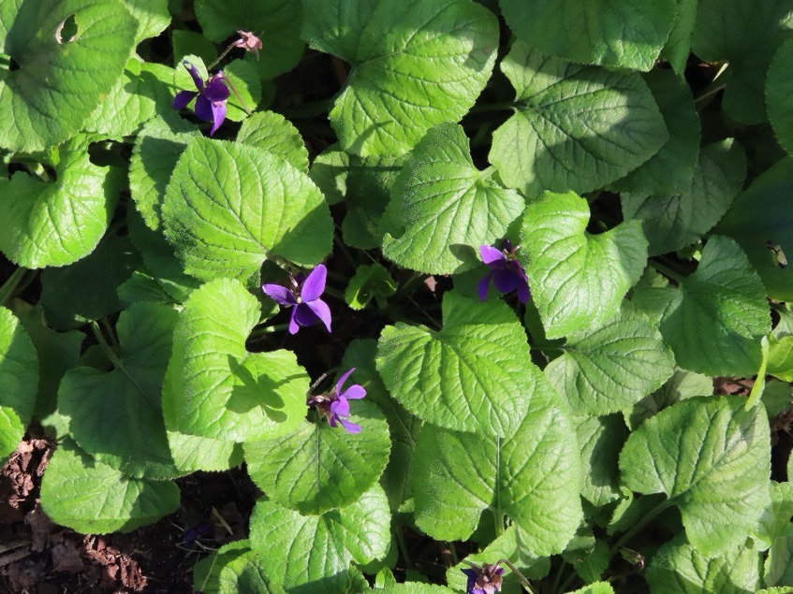
Violets

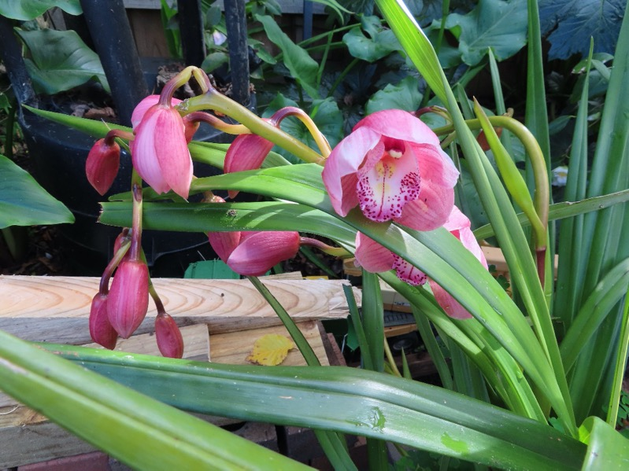

Orchids

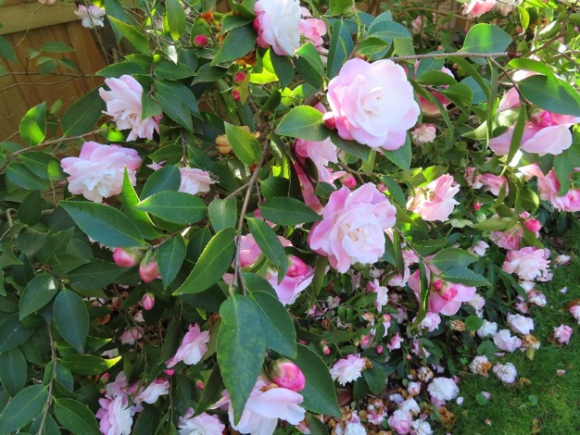
And lots of camellias

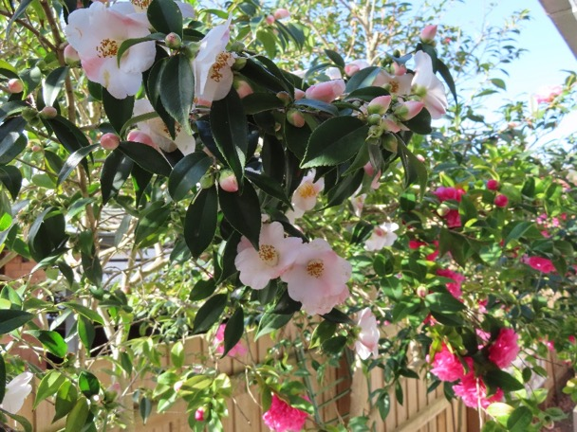
Light pink, dark pink and white.

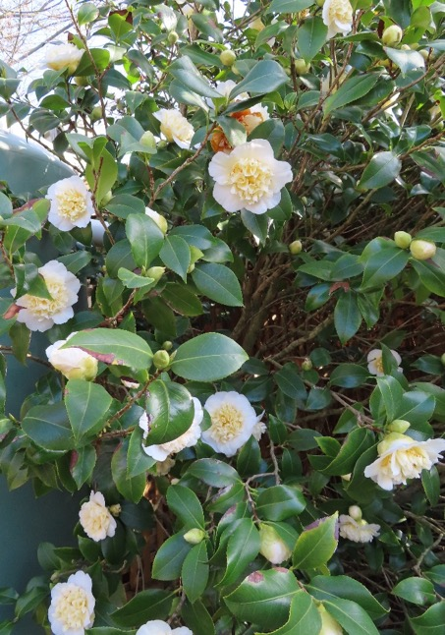

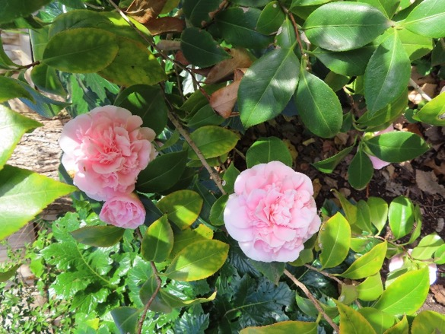
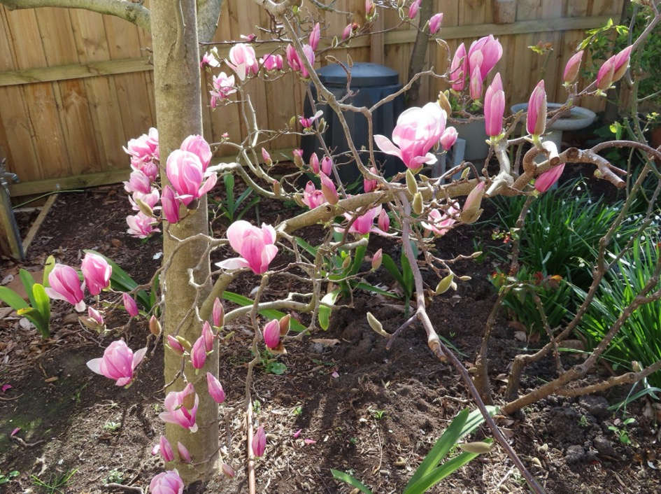
The Magnolia almost hides the compost bin.
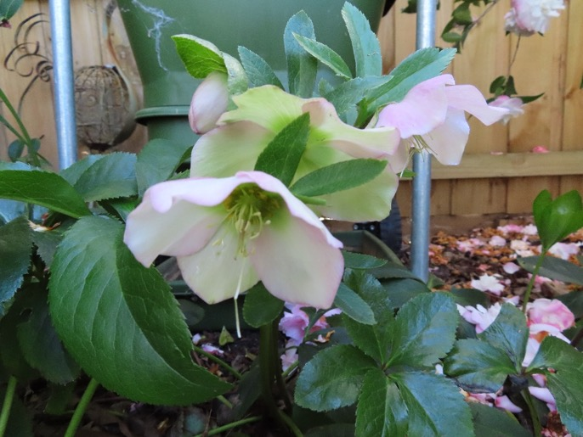
The hellebores are delicate shades of pink.
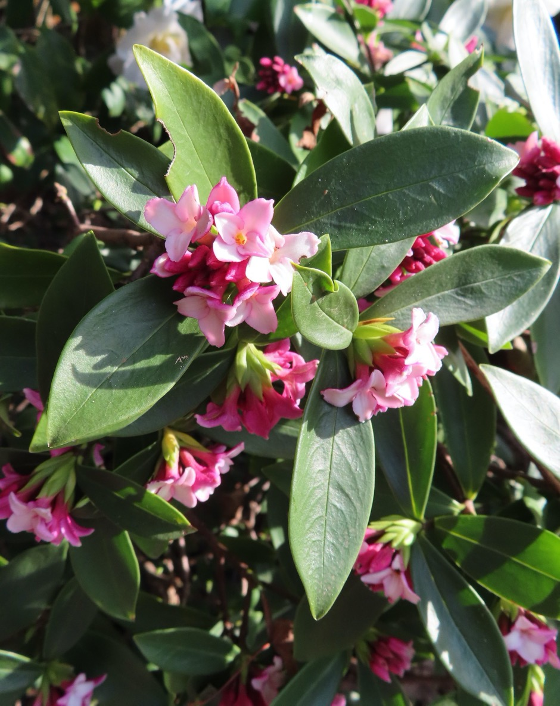
The Daphne has a delicious perfume, but it looks like the insects have been feasting on the leaves.
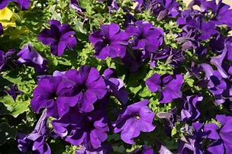
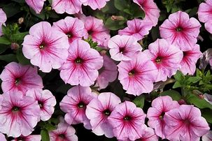
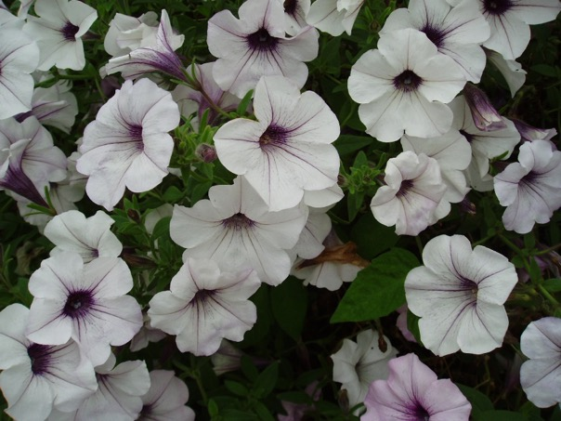
We grow petunias in pots.

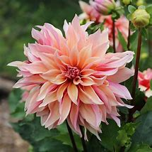
Dahlias

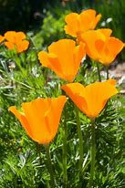

California poppies – the bees love them…
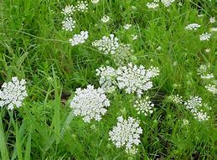

… and they love Queen Anne’s Lace

